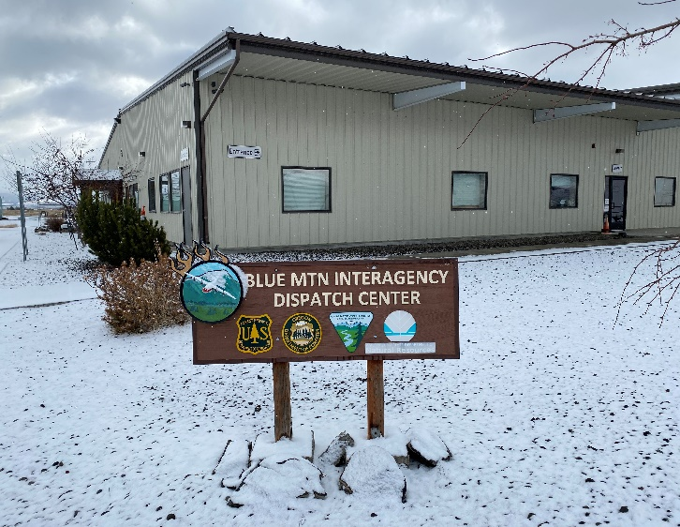 | 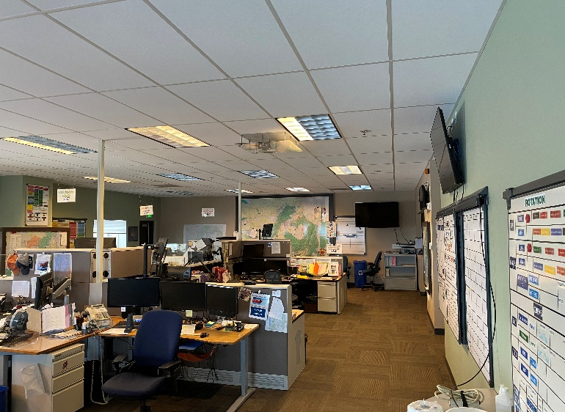

The Blue Mountain Interagency Dispatch Center (BMIDC) was established in 2010 to provide for the safe and efficient mobilization of wildand fire resources. BMIDC is the focal point for coordinating the mobilization of resources for wildland fire, wildland fire use, prescribed fire and all other all-risk incidents throughout Northeast Oregon, Southeast Washington and a small portion of Western Idaho. . The BMIDC footrprint covers close to 7 million acres and we serve 5 federal and state agencies.

Our mission at BMIDC is to provide a service for our users through committed leadership, personal dedication and passion for the safety of all those we serve. It is our commitment to provide efficient and cost effective response while ensuring the safety of the public, our natural resource employees, and our wildland fire fighters. We strive to provide reliable, courteous, responsive and professional communication services.

Every year we have the opportunity to bring interested people into our organization as dispatchers to help support fire fighters on the ground.

For the US Forest Service and through USAjobs, with 90 days of firefighting experience you can apply for an Initial Attack Dispatcher position. As an Initial Attack dispatcher you will be using a Computer Aided dispatch system to dispatch wildland fire fighting resources from five agencies to wildland fires. To ensure the safety of our users you will be monitoring weather reports and radars, fire resource status and availability, clear communication with team members and good documentation.

To support our fire fighters we have positions through Oregon Department of Forestry. These positions provide Logistics support in providing fire fighters additional resources, equipment, supplies, food, and any additional needs to help suppress their fire.

To apply for these positions please monitor this webpage for current openings and how to apply for them.

